**A SIMULATION DESIGN FOR A PLUS AND MINUS 3-VOLT POWER SUPPLY**

Cohlten Green

Ivy Tech Community College

E-mail: [cohltendecker@yahoo.com](mailto:cohltendecker@yahoo.com)

**Abstract**

I was giving the assignment to design a power supply able to power a robotic arm in two directions. In response, I propose a power supply designed to supply a positive 3 volts and a negative 3 volts. This will allow the robotic arm, when giving the command, to use the positive 3 volts to go forward or go backward using the negative 3 volts. This supply design is compatible with 120 volts rms being stepped down, rectified, and regulated to get the plus and minus 3 volts.

**Keywords:** Power supply, plus and minus 3 volts, design, rectified and regulated

**Introduction**

Power supplies are a key feature to electronics. They allow us to harness different levels of electrical power and apply them to a vast array of electronics small and large. In addition to this, power supplies can be very simple to very intricate in how they are designed to operate. The majority of electronics use different power consumptions. Because of this, power supplies must be made specially for each system that they are introduced to. This

provides many different ways to design and create a power supply.

In this paper I will explain the design process, what is needed in making a power supply, how the components work, and showing the simulation along with the analysis of the findings.

**Problem Statement**

As stated earlier in the abstract, I was given the assignment to design a power supply which would power a robotic arm forward and backward. The supply restrictions were that it had to be 3 volts DC and use 100mA of current. In order to make it operate in the two different directions, I needed to have the supply be negative and positive. In addition, it needs to be rectified and regulated to the desired output.

To begin my solution to this assignment, I made a road map and I figured it would be best to work backwards. My output load needs to be plus and minus 3 volts DC and a current of 100mA. Because I am designing a DC power supply, I will need a voltage regulator and a rectifier as well as a transformer, to step down the AC voltage to something more reasonable. Based on this information, I made a skeleton of a design and then added more intricate adjustments.

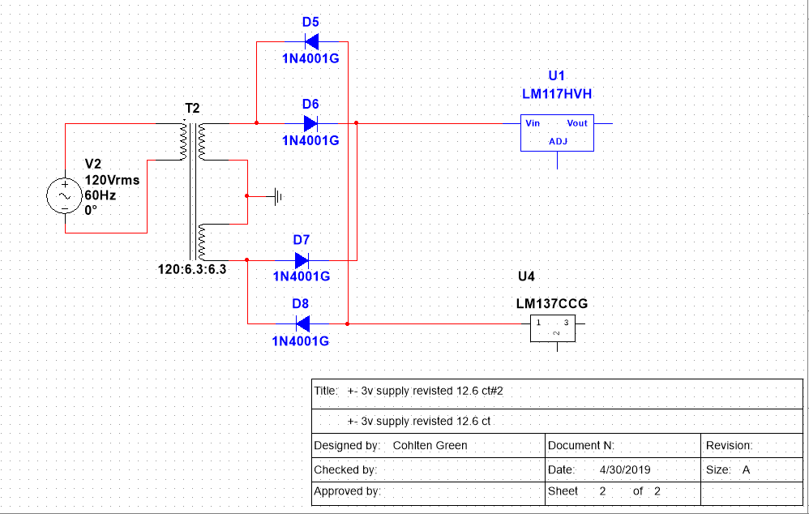*Figure 1. Skeleton design*

I decided to use IC’s LM117 and LM137 for this design. The NI Multisim software that I used did not have an existing component made in their library for the LM137. I had to create my own to make this design work. The LM117 is a positive voltage regulator whereas the LM137 is a negative voltage regulator. I then chose 4 of the 1N4001G diode to make the rectifier and a 12.6v center tap transformer for the step down. This will allow about 6.3v AC to go through both sides of the design. (Figure 1)

**Rectifier**

The rectifier is used to convert the AC voltage to pulsating DC voltage. When choosing a type of rectifier, I had two options, a half wave and a full wave. A half wave only rectifies half of the AC cycle into pulsating DC. So, a positive or negative pulsating DC voltage. Whereas the full wave rectifier rectifies the full AC cycle into pulsating DC voltage. I chose a full wave rectifier because I needed to have a positive and negative output for my power supply design. The diodes chosen for my design were 1N4001G (figure 2).

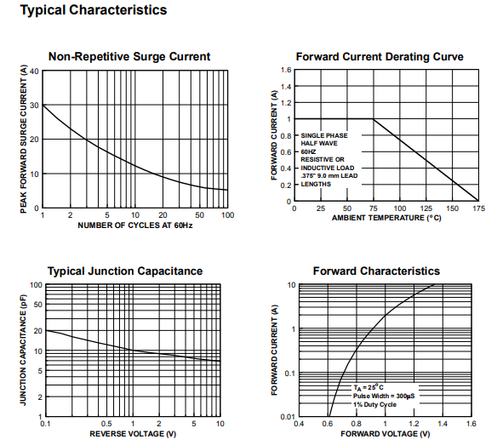*Figure 2. Diode 1N4001G characteristics*

**Filter Design**

When designing the filter, there were many different options to choose from and different ways to make each one. (Figure 3 and 4)

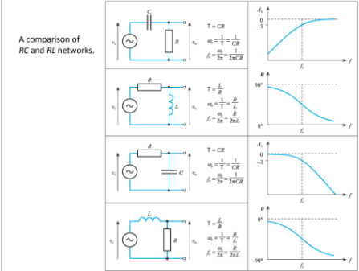*Figure 3. RL and RC filters (Ayla Russel, 2015)*

These filters will allow only certain frequencies to pass through while getting rid of the others. For example, a low pass filter will only allow low frequencies to pass through it and get rid of higher frequencies. The same idea works with high pass filters.

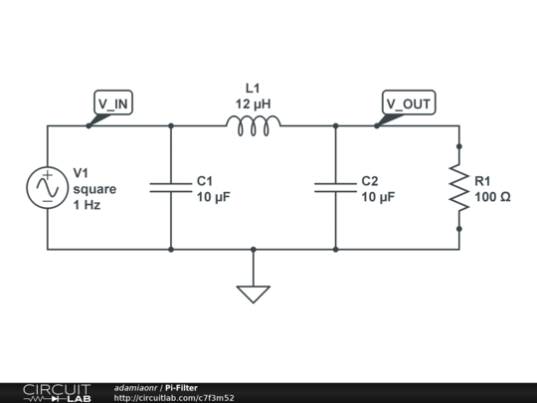*Figure 4. PI filter (Adamiaonr, "Pi-Filter", 2019)*

In my design, I chose to use a low pass pi filter because this design uses low frequencies. I did, however, replace the inductor with a resistor in each of the filters (Figure 5).

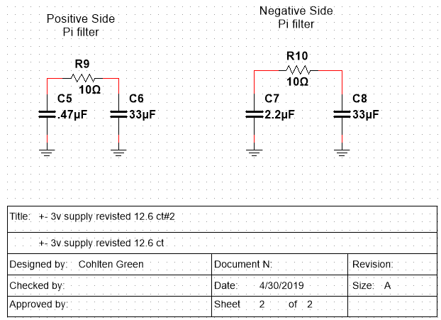*Figure 5. Positive and negative pi filters*

To get the filters to work, I troubleshot each one by putting different values for each until it came out to be correct. I knew that I needed a small value resistor in between the capacitors. I also knew that one capacitor of each filter would have to be a bit bigger than the other. That gave me an advantage on finding the correct setup.

**Voltage Regulators**

Like I stated earlier, I chose the IC’s LM137 and LM117. These two IC’s are very easy to use and only require two external resistors to control the output. The LM117 can supply 1.5A over a 1.2V to 37V output range (figure 6). Likewise, the LM137 can supply -1.5A over a -1.2v to -37v output range (figure 7). To tune/adjust the external resistors to exactly what you need your output to be, I found a formula for each on their datasheets (figure 8 and 9). By manipulating the equations, you can solve for the exact resistance that you need your R2’s to be for each regulator. It’s best to put a potentiometer or variable resistor in the design to get the exact resistance needed. Otherwise you may waste space, components, or cost trying to get the exact resistance needed to get the desired output.

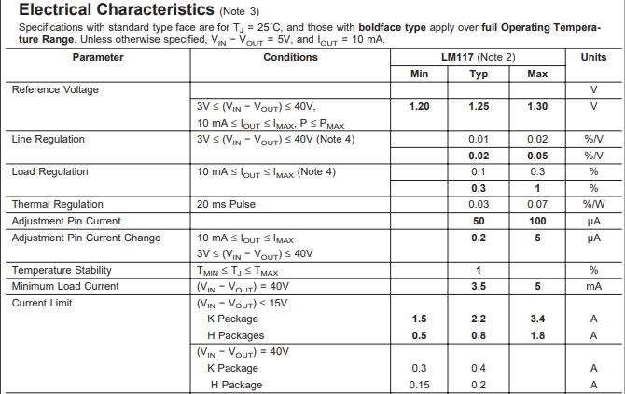*Figure 6. LM117 characteristics*

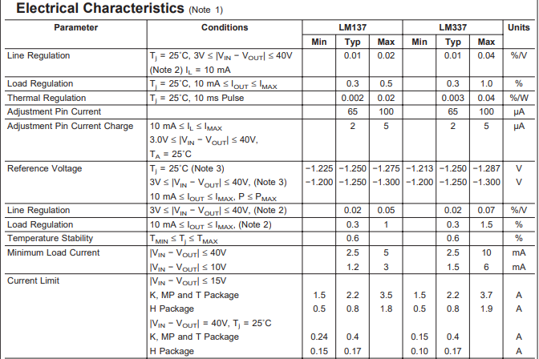*Figure 7. LM137 characteristics*

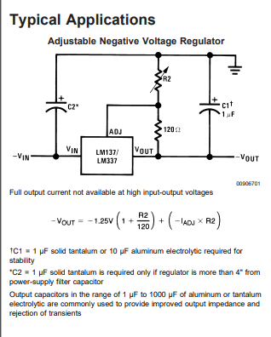*Figure 8. Negative voltage regulator*

**Transformer**

The transformer allows you to step the AC voltage down to a more reasonable and desirable voltage. The distributor that my instructor goes through only had options for center tap transformers for 6.3v, 12.6v ,24v, 25v, and 30v with varying currents for each. For a positive and negative 3v power supply, I knew the 24v, 25v, and 30v center tap transformers would be too much. You

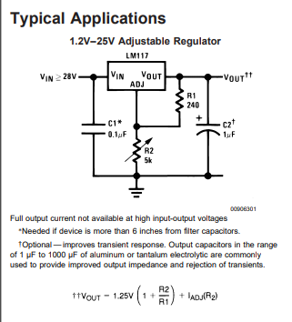*Figure 9. Positive voltage regulator*

would waste quite a bit of energy using those. The 6.3v was too small for my design. The 12.6v was more reasonable for my design. I chose the 6.3v because it is almost perfect for the design. There isn’t much power wasted and it is cost efficient.

**The Design Put Together**

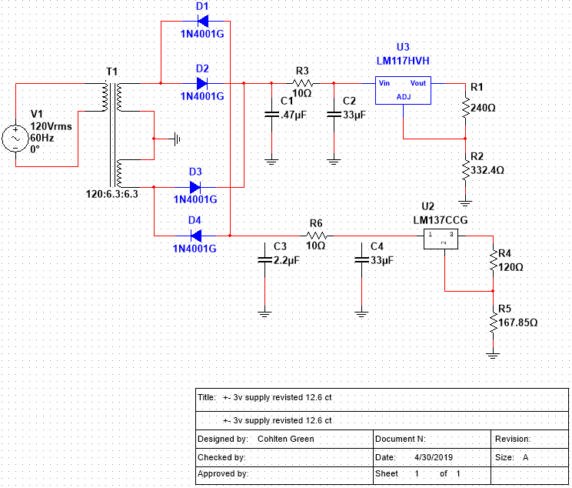*Figure 10. Complete design without load*

After all that was figured out, the full design was put together. Figure 10 shows what the final design looks like without an output load. The parts list is the following:

*Figure 11. Parts list*

**Analysis**

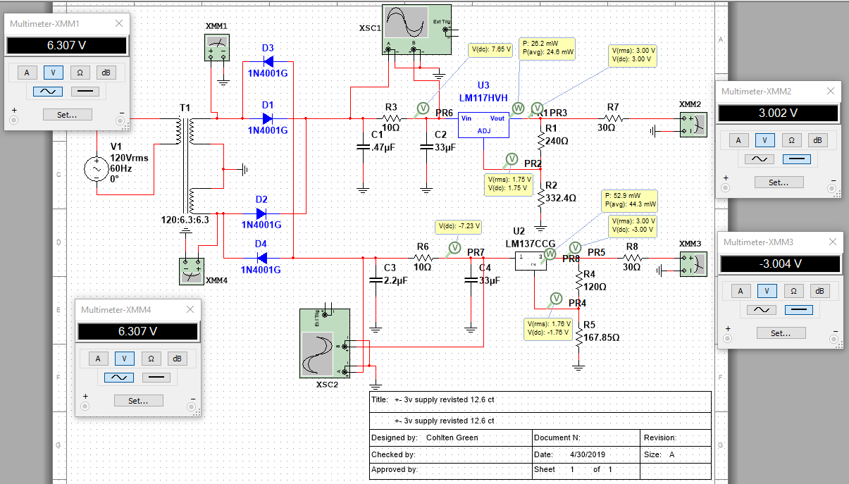*Figure 12. Circuit analysis*

In figure 12 you will see the full design with analysis of the circuit and values. Starting from the left, the two multimeters show that there is about 6.3 AC voltage going to both the positive and negative sides. The top portion of the rectifier changes the AC voltage to positive pulsating DC voltage while the bottom portion changes it to negative. This leads to the filters. I have an oscilloscope connected to each filter to monitor the frequencies and waveforms. The wave forms for each are shown in figures 13, 14, 15, and 16. I then have a probe right after each resistor in each of the filters.

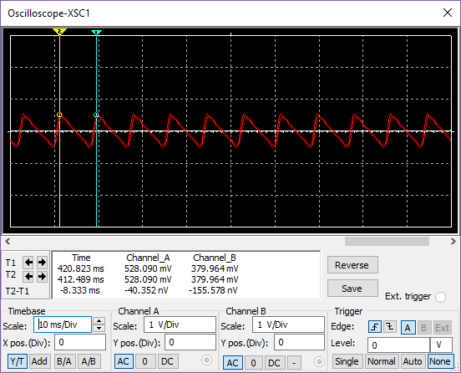*Figure 13. AC, channel A before, channel B after positive filter*

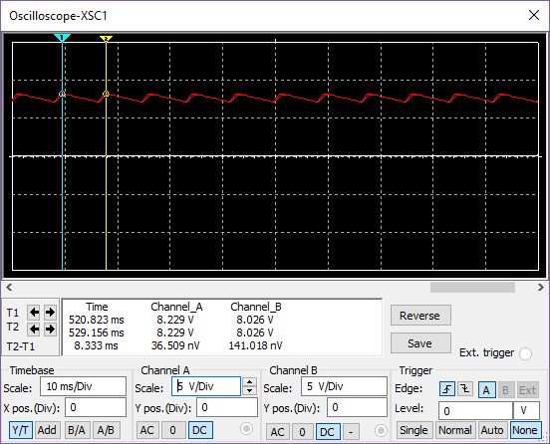*Figure 14. DC, channel A before, channel B after positive filter*

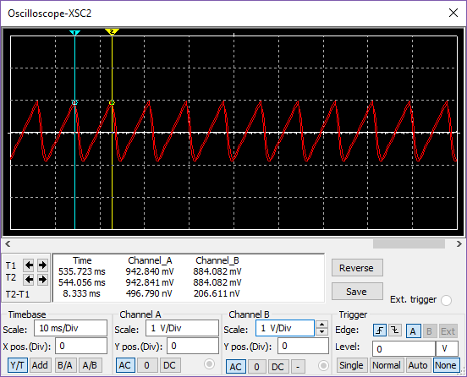*Figure 15. AC, channel A before, channel B after* *negative filter*

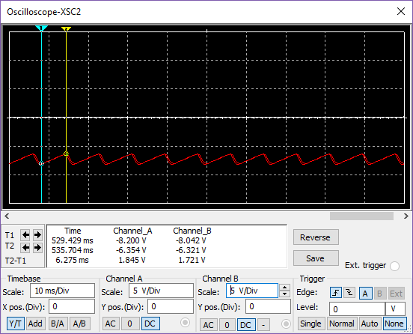*Figure 16. DC, channel A before, channel B after* *negative filter*

These probes show the voltage that is going into each of the voltage regulators. It takes 5v to power each of the voltage regulators. The probes read 7.65v for the positive side and -7.23v for the negative side. Before I added my load resistor, I added a probe after each regulator to see how much voltage I had. I then calculated the correct values for each of the external resistors for each regulator. To finish up the design, I added a load resistor based on the requirement asked of. This being positive and negative 3v at 100mA. Using ohm’s law, I found the resistance needed and added the resistor with that value for each side.

**Fourier Analysis**



***Figure 17. Waveform analysis***

I completed a Fourier Analysis on my power supply across the filters of each side. I expected both of them to be the same and I was correct. I first began by connecting an oscilloscope across the filter. I then ran the simulation and found the period. I took the inverse of the period to find the frequency which is shown in figure 17. After that I ran the Fourier Analysis and found six different harmonics along with their characteristics. This is shown in figure 18. This then led me to adding each of the frequencies together by using voltage summers (figure 19). This will allow me to input the frequency, magnitude, and its phase in each of the summers and add them together. Once all of this has been completed, I connected all of the summers to channel A of an oscilloscope and connected the point right after the filter to channel B.

*Figure 18. Fourier analysis*

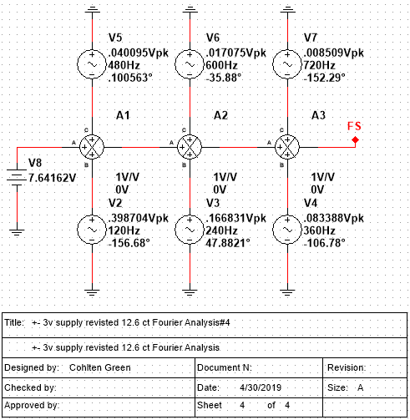*Figure 19. Voltage summers*

By doing this, I reassured that I completed this Fourier analysis correctly. It gave me the same frequency as what I originally had. This includes the same period as well. The results are shown in Figure 20.

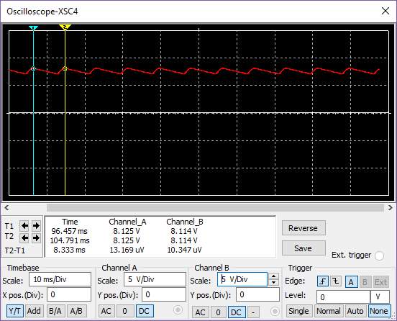*Figure 20. New frequency*

**Power consumption**

As part of designing this circuit, I tested each part in the simulation for power consumptions. This is something needed to be done in case parts got too hot or were to overheat. In the case that they would overheat however, you would need to invest in a heatsink for the part. In figure 21, these are all the parts accompanied with how much power they produce. None of these parts will need a heat sink added, especially the IC’s used. When looking at the datasheet for both the LM137 and LM117, it will inform you that each IC has an internal thermal overload protection.



*Figure 21. Power consumption analysis*

**Related Work**

There are a lot of related works done in conjunction with power supplies. Some of these power supplies would include (ELPROCUS, 2018):

* Variable
* Dual
* Unregulated linear
* Computer
* Programmable
* DC
* UPS (uninterruptible power supply)

As I stated earlier, depending on what is needed or requested, the magnitude of variety to make a power supply is plentiful.

**Conclusions**

To conclude this technical paper, the over all design went according to plan and was made successfully. As a follow-up on what was presented in this paper, I talked about the different components used, how they work, the design of the power supply, data and analysis. In addition, this paper presents the work flow and almost step-by-step procedure of how the power supply was completed.

**Bibliography**

I am an engineering student at Ivy Tech Community College studying electrical engineering.This technical paper is an assignment giving to me for my capstone class in order for me to graduate. In addition to my knowledge of electrical engineering, I have experience in a few drafting programs such as AutoCAD, Inventor, and Solid Works.

**References**

A. R. (n.d.). Frequency Characteristics of AC Circuits - ppt video online download. Retrieved April 30, 2019, from <https://slideplayer.com/slide/4173299/>

Pi-Filter. (n.d.). Retrieved April 30, 2019, from <https://www.circuitlab.com/circuit/7f3m52/pi-filter/>

Power Supply Classification and Its Various Types. (2018, December 05). Retrieved April 30, 2019, from <https://www.elprocus.com/classification-power-supply-different-types/>